PAF-Karachi Institute of Economics & Technology
(The Center of Excellence)
College of Computing and Information Sciences
Course Project Proposal Form

Sno. | Stud. ID | Names | Course Name/CID
1 | 12413 | Safiullah Rehmani | 105726
2 | 12441 | Zain Masroor Sharfi

Project Title: The Archangels of Islam

- Motivation:
The main purpose of choosing this topic is; we can get a lot of detail which would help us make our website much more dynamic and add some of the features we couldn’t really add with other topics. Moreover, It’s a topic we relate to our everyday life.
- Functional Features
- Functional features for our project will be really basic that all the Information websites have with a lot of attractive layouts and it being user friendly.

- Start with the most significant feature.

- Detailed Introduction and Characteristics of the Archangels with Quran and Hadith References.

Second most significant feature.

- Different Youtube videos and Information in form of Images and associated Ayaat of the Quran with Translation.

More Addons:

- Detailed Intending and Aligning.
- YouTube video links for respective section.
- User friendly using CSS.
- Images associated with each topic and that particular page.

3. Project Planning

We like to take things to step by step and see what we can do to help make our project stand out.

OUTPUT SCREENSHOTS:

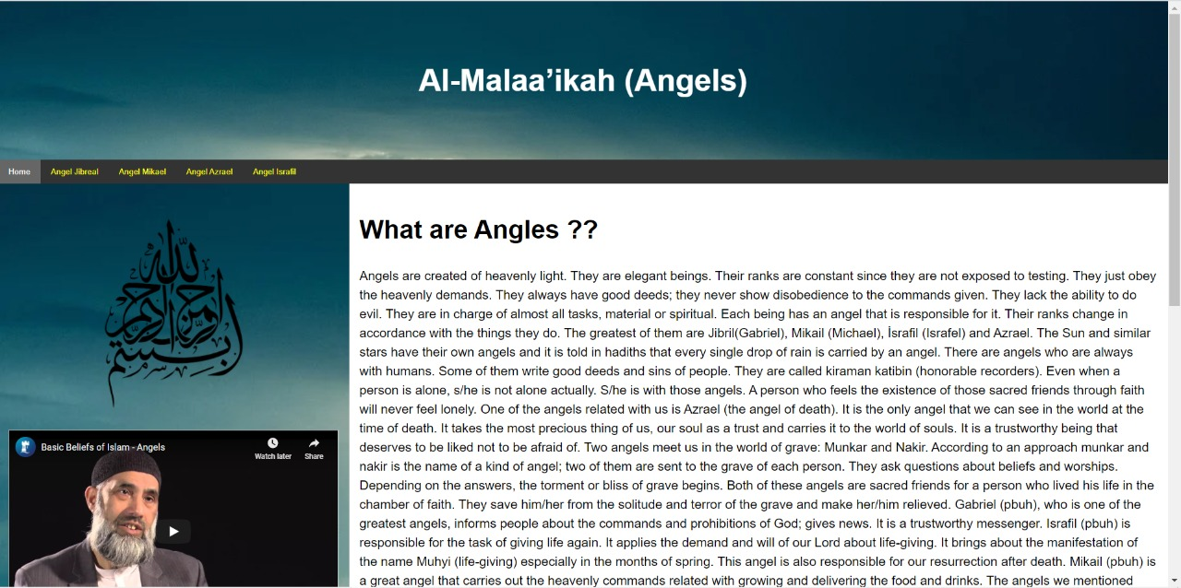

Screen 1 output shows the Introduction of Angels that how they were created and who are they? What are their ranks? What do They do? What are their responsibilities? Also gives a brief Intro to the 4 Big Archangels of Islam. And also mentioned the Ayat of the Quran with its Translation.
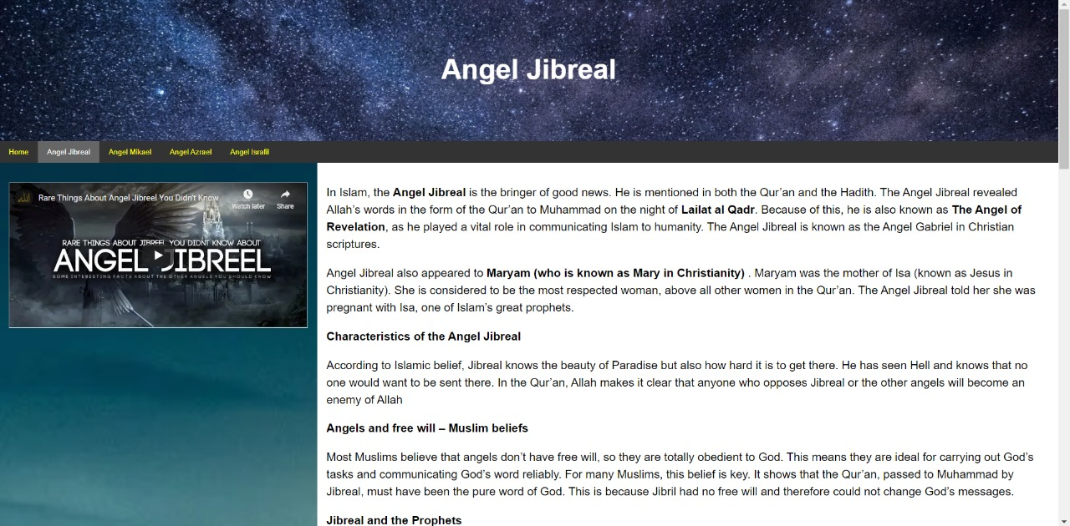

Screen 2 output shows about the Angel Jibrael as he was the bringer of the good news also he is mostly associated with the Prophets to guide them by the command of Allah(SWAT).In the Qur’an, Allah makes it clear that anyone who opposes Jibreal or the other angels will become an enemy of Allah. And also mentioned the Ayat of the Quran with its Translation.

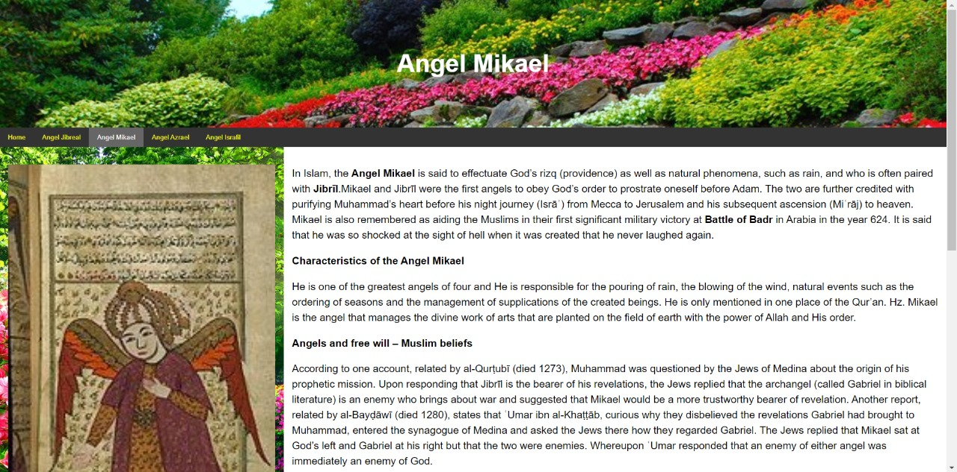

Screen 3 output shows as In Islam, the Angel Mikael is one of the greatest angels of four and He is responsible for the pouring of rain, the blowing of the wind, natural events such as the ordering of seasons, and the management of supplications of the created beings. Mikael is the angel that manages the divine work of arts that are planted on the field of the earth with the power of Allah and His order.

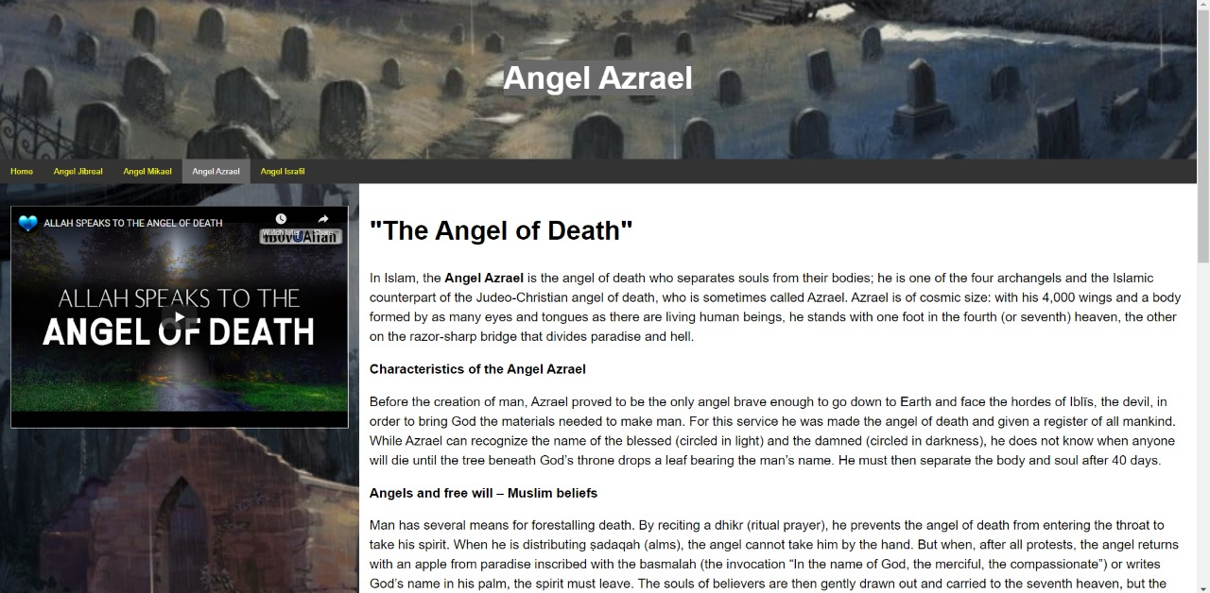
Screen 4 shows that In Islam, the Angel Azrael is the angel of death who separates souls from their bodies; he is one of the four archangels and the Islamic counterpart of the Judeo-Christian angel of death, who is sometimes called Azrael. Azrael is of cosmic size: with his 4,000 wings and a body formed by as many eyes and tongues as there are living human beings, he stands with one foot in the fourth (or seventh) heaven, the other on the razor-sharp bridge that divides paradise and hell. And also mentioned the Ayat of the Quran with its Translation.

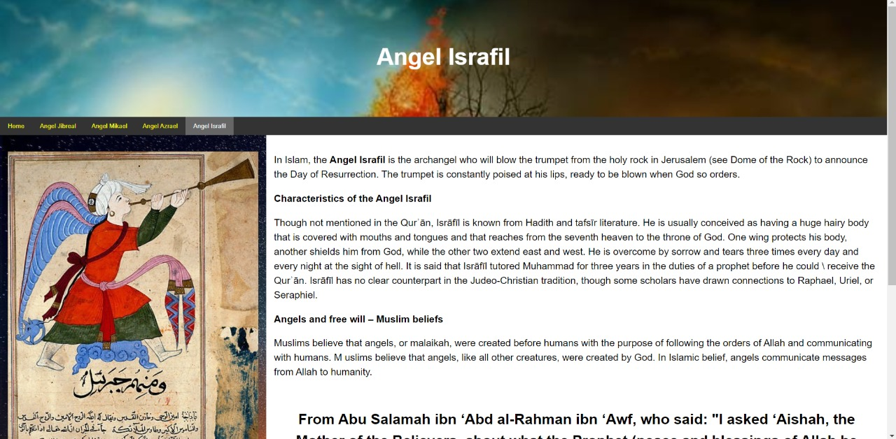

Screen 4 shows that In Islam, the Angel Israfil is the archangel who will blow the trumpet from the holy rock in Jerusalem (see Dome of the Rock) to announce the Day of Resurrection. The trumpet is constantly poised at his lips, ready to be blown when God so orders. And also mentioned the Ayat of the Quran with its Translation.

